

Annual Consent Compliance Report

Ōtaki Wastewater Treatment Plant

2019/20

Annual Consent Compliance Report

Ōtaki Wastewater Treatment Plant

2019/20

Kāpiti Coast Water Conservation Report  
2018/19

2013/14 Annual Water Conservation Report

prepared by Kapiti Coast District Council – July 2014

<Page intentionally left blank>

Revision History

|  |  |  |  |
| --- | --- | --- | --- |
| Revision Nº | Prepared By | Description | Date |
| V0 | Melissa Smith | Draft for Richard Millican | 16/09/2020 |
| V1 | Melissa Smith | Draft for Richard Millican | 23/09/2020 |
| V2 | Melissa Smith | Draft for Richard Millican | 08/10/2020 |
| V3 | Melissa Smith | Draft for Richard Millican | 04/11/2020 |
| V4 | Melissa Smith | Interim Review - Richard Millican/ Martyn Cole | 27/11/2020 |
| V5.1 | Melissa Smith | Final Review Richard Millican (*minor amends.)* | 07/1/2021 |

Document Acceptance

|  |  |  |  |
| --- | --- | --- | --- |
| Action | Name | Signed | Date |
| Prepared by | Melissa Smith |  | 18/12/20 |
| Reviewed by | Richard Millican |  | 8/1/21 |
| Approved for issue by | Martyn Cole | pp: | 8/1/21 |
| on behalf of | Kāpiti Coast District Council | | |

**Executive Summary**

This report has been compiled in accordance with Resource Consent Permit No. WGN160002. The consent allows Ōtaki Wastewater Treatment Plant (WWTP) to discharge treated effluent to land to a Land Discharge and Treatment Area (LDTA) and contaminants to air from the operation of the plant.

This report steps through the various consent conditions and reports their status and/or compliance for the period 1 July 2019 to 30 June 2020.

For this consent period, the Ōtaki WWTP has experienced a delay in the planned LDTA optimisation programme due to a shortage of resources, delays in engagement with the supply chain and supply issues with materials such as region specific harakeke. The tender for the optimisation work has gone out and tenders have been received. Completion is expected in mid-April 2021. These delays are explored more in sections 3.1 (p. 3), 4.3 (p. 6), and 4.4 (p. 6).

There is also concern around maximum inflow into the WWTP with time (a Condition directs the review of this against a stated future population and projected flow value) - predictions around population and inflow rates have been investigated on behalf of KCDC by Cardno, in a Condition and Capacity Study carried out his year, and are now revised. At this stage, the WWTP is looking at exceeding the average inflow rate of 2,090 m3/day before 2035 as stipulated in this consent, as the Ōtaki population is expected to exceed 6,520 before 2035 as well. See sections 4.1.1 (p. 4) and 5.2.1 (p. 8) for details on this.

The Ammoniacal nitrogen levels in the ponds have been consistently exceeding the limits stipulated in condition 17 of this consent. KCDC believe this could be dumping to sewer from a local cleaning products manufacturer/ stockist, as well as faeces from waterfowl at the WTTP. Details on these exceedances and explanation in section 5.4.1.4 (p. 16).

Under conditions 19 and 20, there was a breach of E.coli coliforms in Bore 5 that was not resampled, investigated, reported to Greater Wellington Regional Council (GWRC). More details on this breach can be found under section 5.5.2 (p. 21).

Bores 4, 5, and the spring have breached the limits stipulated in condition 21. However, KCDC believe that these limits need to be discussed with GWRC, as the results from samples taken since 2016 have consistently been above these limits. A data table for each monitoring bore, as well as data for bores 4, 5, and spring, over the compliance period can be found under section 5.5.4 (p. 22).

Reporting on this consent was late, due to uptake of new staff/ roles and data collation issues. This will be rectified for future reports and data will be more readily available when KCDC move Wastewater testing and operations over WaterOutlook; retiring the current Microsoft Access database next financial year 2020/2021.

A summary of the 2019/2020 performance against the resource consent conditions is provided in Table 1-1.

|  |  |
| --- | --- |
| Key |  |
|  | No triggers or actions needed |
|  | Trigger or action |
|  | Exceedance |

|  |  |  |
| --- | --- | --- |
| Table 1-1 Monitoring Conditions to Resource Consent |  |  |
| **Conditions to Resource Consent** | **Compliance** |  |
| General Conditions | 1 & 2 |  |
| LDTA Optimisation | 3, 4 & 5 |  |
| Operations and Maintenance | 6, 7 & 8 |  |
| Maximum Discharge Rate | 9 & 10 |  |
| Maintaining Wet Weather Storage and maximum inflow | 11 |  |
| Wastewater Volume Measurement | 12, 13 & 14 |  |
| Monitoring of Pond Effluent Quality | 15 & 16* |  |
| Soluble Carbonaceous BOD | 17 a) |  |
| Total Suspended Solids | 17 b) |  |
| Faecal Coliforms | 17 c) |  |
| Ammoniacal Nitrogen | 17 d) |  |
| Dissolved Reactive Phosphorus | 17 e) |  |
| Monitoring of Groundwater and Spring Water | 18* |  |
| *E. coli* and Soluble Inorganic Nitrogen in Bores 4 & 5 | 19 & 20 |  |
| Attenuation Equilibrium, Bores 4, 5 and Spring | 21 |  |
| Inspection Records and Operational | 22 |  |
| Monitoring Requirements | 23 |  |
| Performance and Maintenance of the Distribution System | 24, 25 & 26 |  |
| Reserve Area for Effluent | 27 |  |
| Inflow and Infiltration Investigations, Works and Reporting | 28 |  |
| Odour | 29, 30, 31 & 32 |  |
| Planting within the Land Discharge & Treatment Area | 33, 34 & 35 |  |
| Perimeter Planting | 36 |  |
| Fencing and Signage | 37 |  |
| Iwi Consultation | 38 & 39 |  |
| Community Liaison | 40 |  |
| Complaints | 41 |  |
| Incident | 42 |  |
| Reporting | 43 |  |

Contents

1 Ōtaki Wastewater Treatment Plant 1

2 Operation of Ōtaki Wastewater Treatment Plant 1

2.1 Iwi Consultation 1

2.2 Community Liaison Group 1

2.3 Complaints 1

2.4 Odour Management 2

2.5 Performance and Maintenance of the Distribution System 2

2.6 Reserve Area for Effluent Discharge 3

3 Optimisation of Operation 3

3.1 LDTA Optimisation Report (KCDC & NHoŌ) 3

3.2 Operations and Maintenance Manual 3

3.3 Inflow and Infiltration Investigations, Works, and Reporting 3

4 Asset Investment 4

4.1 WWTP Asset Management 4

4.2 Fencing and Signage 6

4.3 Implementation of Changes to LDTA 6

4.4 Planting for the LDTA upgrades 6

5 Compliance Monitoring and Analysis 7

5.1 Maximum Discharge Rate 7

5.2 Wet Weather Storage 8

5.3 Monitoring of Wastewater Flows 8

5.4 Pond Effluent Quality 8

5.5 Ground Water and Spring Water Quality 20

5.6 Incident Notification 23

**Appendices**

**Appendix A** Flow & Sampling Records

**Appendix B** Network Management Improvement Programme

**Appendix C** Ōtaki Wastewater Treatment Plant Suspected Dumping Incidents

**Appendix D** Ōtaki Wastewater Treatment Plant Resource Consent WGN160002

|  |  |  |
| --- | --- | --- |
| **Tables** |  | |
| Table 1-1 | Monitoring Conditions to Resource Consent | iii-iv |
| Table 5-1 | Water Quality – Bores 4 and 5 | 21 |
| Table 5-2 | Bore 4, 5 and Spring Water Quality | 22 |
| Table 5-3 | Bore Averages 2016 Onwards | 23 |

**Figures**

|  |  |  |
| --- | --- | --- |
| Figure 5-1 | Treated Effluent Discharged to LDTA | 7 |
| Figure 5-2 | ScBOD5 Concentration in Pond A Effluent | 10 |
| Figure 5-2a | Boxplot: ScBOD5 Concentration in Pond A Effluent | 10 |
| Figure 5-2b | ScBOD5 Concentration in Pond B Effluent | 11 |
| Figure 5-2c | Boxplot: ScBOD5 Concentration in Pond B Effluent | 11 |
| Figure 5-3 | TSS Concentration in Pond A Effluent | 12 |
| Figure 5-3a | Boxplot: TSS Concentration in Pond A Effluent | 12 |
| Figure 5-3b | TSS Concentration in Pond B Effluent | 13 |
| Figure 5-3c | Boxplot: TSS Concentration in Pond B Effluent | 13 |
| Figure 5-4 | Faecal coliform Concentration in Pond A Effluent | 14 |
| Figure 5-4a | Boxplot: Faecal coliform Concentration in Pond A Effluent | 14 |
| Figure 5-4b | Faecal coliform Concentration in Pond B Effluent | 15 |
| Figure 5-4c | Boxplot: Faecal coliform Concentration in Pond B Effluent | 15 |
| Figure 5-5 | Ammoniacal Nitrogen Concentration in Pond A Effluent | 16 |
| Figure 5-5a | Boxplot Ammoniacal Nitrogen Concentration in Pond A Effluent | 17 |
| Figure 5-5b | Ammoniacal Nitrogen Concentration in Pond B Effluent | 17 |
| Figure 5-5c | Boxplot Ammoniacal Nitrogen Concentration in Pond B Effluent | 18 |
| Figure 5-6 | DRP Concentration in Pond A Effluent | 19 |
| Figure 5-6a | Boxplot: DRP Concentration in Pond A Effluent | 19 |
| Figure 5-6b | DRP Concentration in Pond B Effluent | 20 |
| Figure 5-6c | Boxplot: DRP Concentration in Pond B Effluent | 20 |

# Ōtaki Wastewater Treatment Plant

The Ōtaki Wastewater Treatment Plant (WWTP) was granted a revised resource consent permit (WGN160002) to discharge treated effluent to land to a Land Discharge and Treatment Area (LDTA) and contaminants to air from the operation of the plant, in October 2016. As part of this consent, the Kāpiti Coast District Council (KCDC) must provide a compliance report on the performance of the plant against the parameters presented in the permit.

Under condition 43 of this consent, KCDC must provide the compliance report for the previous financial year, and present it to the Manager, Environmental Regulation, Wellington Regional Council by 30 September. The period covered in this report is 1 July 2019 to 30 June 2020.

This report outlines the required consent conditions and reports their status and/or compliance.

# Operation of Ōtaki Wastewater Treatment Plant

## Iwi Consultation

Condition 38 and 39 require KCDC to invite Nga Hapu o Ōtaki (NHoŌ) to a yearly briefing and inform them of any changes onsite.

### **Compliance**

Iwi consultation is imbedded in the design of the LDTA, and therefore KCDC have been working closely with NHoŌ throughout this process. KCDC worked closely on the LDTA Optimisation Study with NHoŌ during the last compliance period.

With ongoing upgrade work, KCDC will continue to inform and engage Iwi representatives, including employing local specialists and using local supply chains. The planting and fencing contractors that have been engaged have a clear connection to NHoŌ, and the Ōtaki community, which will assist in future with site management, including harvesting by Iwi.

## Community Liaison Group

Condition 40 requires the establishment of a community liaison group for the Ōtaki WWTP.

### **Compliance**

KCDC have previously advertised the establishment of a community liaison group for the Ōtaki WWTP, but unfortunately, the community did not express any interest. KCDC will endeavour to canvas key local stakeholders regarding interest in this liaison group again, and will report back in the 2020/2021 annual consent compliance report, having gauged current interest.

## Complaints

Condition 41 requires KCDC to maintain a permanent record of complaints relating to the Ōtaki WWTP and LDTA.

### **Compliance**

No complaints have been received during the compliance period.

## Odour Management

Conditions 29 to 32 refer to odour management at the site.

### **Compliance**

There have been no odour complaints related to the Ōtaki WWTP or LDTA during the compliance period.

Odour control is managed by the use of a carbon filter (upgraded July 2020) for air from the main sludge dewatering building, and a biofilter is used for the rest of the sludge management system.

The biofilter was due to be refurbished, and had been planned for some time, however it was delayed due to supply chain problems. The refurbishment was completed in October 2020, and included a new liner and media. A further amount of media was delivered in December 2020 to account for media settlement.

## Performance and Maintenance of the Distribution System

Condition 24 refers to the operation and maintenance of the distribution system. For infiltration of the discharge area is maintained, KCDC need to ensure:

* Even distribution across the discharge area, and that effluent is applied to no less than 75% of the area
* Ensuring there is no ponding in the distribution zones prior to next application, and that any ponding does not exceed 24 hours under dry conditions
* There is no surface flow redistribution within the discharge area of more than 10m under dry weather flow conditions

### **Compliance**

Currently the LDTA (10.8 hectare) is divided into six zones, each with 3 distribution laterals. Each zone is selected for use by manually opening the lateral valves at the distribution pipe. Effluent is applied to one zone at a time (3 laterals) up to the maximum discharge rate of 2,820m3/day (Condition 9) and to manage the maximum hydraulic application rate, to not exceed a maximum effluent depth of 155mm/day (Condition 10). The zones are manually changed. The fixed speed irrigation pump currently operates intermittently, to fill the three effluent feed columns. Once the maximum volume for that day is delivered, a valve opens to redirect flows to the storage pond. The pond outlet weirs hydraulically separate the ponds from the irrigation wet well.

In view of the Optimisation Report, appended to this report (under Section 3.1), upgrades to the LDTA distribution system include the replacement of both the effluent pumps (on Variable Speed Drive), removal of the three header chambers and replacement of the header pipe. Automated valves on each of the laterals will also be included, as part of a more sophisticated control system for the programmed distribution of effluent.

The effluent pump speeds will be cycled such that the effluent ‘throw’ range from the laterals will vary to allow for a more even distribution from the laterals, and a uniform distribution to each lateral. This was discussed with stakeholders during the consent renewal process, and during development of Optimisation Study under condition 4. The current system is not optimal.

The operations team can now optimise the distribution with the following tools:

1. Automated lateral distribution selection system
2. Ability to manually change order of distribution events
3. Ability to utilise historical data, and optimise future operation based on this more accurate history

Tenders for the LDTA upgrade have been received, and KCDC awarded the contract in December 2020.

## Reserve Area for Effluent Discharge

Condition 27 requires the maintenance of 5.45ha of land to be maintained in close proximity to the LDTA for future disposal capacity.

### **Compliance**

KCDC continues to own the field adjacent to the LDTA which exceeds this plan area.

# Optimisation of Operation

## LDTA Optimisation Report (KCDC & NHoŌ)

Condition 4 requires KCDC to prepare a report in collaboration with Nga Hapu o Ōtaki (NHoŌ), which discusses and agrees on any proposed changes to the LDTA, as a result of the Optimisation Study, February 2018.

### **Compliance**

1. The Optimisation Study Report (Condition 3) was completed in February 2018.
2. It is worth noting that the Optimisation Study (Condition 3) was prepared by Cardno in collaboration with KCDC and NHoŌ, such that the collaboration required under Condition 4 had already occurred prior to the completion of the Optimisation Study in Condition 3.
3. GWRC were provided with a copy of the optimisation Report for their consideration and was peer reviewed by Hamish Lowe who agreed in principle with the Report conclusions and recommendations.

## Operations and Maintenance Manual

Conditions 6-8 refer to the Operations and Maintenance Manual (OMM) for the Ōtaki WWTP. The OMM needs to be updated once the LDTA Optimisation Report has been approved, or at least 3-yearly from 2019 onwards.

### **Compliance**

There have been no further changes to the OMM as upgrades to the LDTA will be starting in the 2020/2021 financial year. Once works have been completed, the OMM will be updated, and a copy will be supplied to GWRC.

## Inflow and Infiltration Investigations, Works, and Reporting

Condition 28 requires KCDC to continue to investigate and implement ways and means of minimising stormwater inflow and infiltration (I/I) into the sewerage system. Condition 43 (annual report) requires commencement summary of I/I work for the previous 3 years, and a schedule for the next 3 years.

### **Compliance**

Reporting on this condition is not required for the 2019/2020 annual report, however, KCDC do have some updates.

With reference to Appendix B of KCDC’s 2018/2019 compliance report, KCDC have rolled out the work as planned. An updated version of this activity schedule has been attached in Appendix B of this report.

Timing has been amended to reflect the status of the project; actions in the near future are:

* Development of an adaptive management strategy that will inform the Long Term Plan on level of service.
* Budget is assigned to the asset renewal model to investigate network performance such as enhancements to flow gauging, and condition assessment such as CCTV inspection.
* The proposed containment standard, as currently drafted proposes for insertion in to long term asset planning:
* works critical now (asset renewal/upgrades)
* works to accommodate growth (revised for Long Term Plan 2021, for 30 years; incorporating delayed/incomplete information from the 2018 Census)
* works to accommodate climate change (hydraulic model revised to account for the most recently understood Climate Change factors).

The next formal report is due in 2022.

# Asset Investment

## WWTP Asset Management

Cardno started assessments in June 2019, and provided the Condition and Capacity Report to KCDC on 3 June 2020. Council are deploying this information in the current development of the Activity Management Plan (AMP) 2021 and 30-Year Long Term Plan (LTP) 2021.

### **Condition and Capacity Study Asset Condition**

Cardno suggested that the major **high priority improvement works** to process assets are:

* LDTA upgrade
* New inlet screen
* Internal refurbishment of the clarifier
* New clarifier drive
* Centrifuge refurbishments

**Flows and loads projections:**

Cardno found that because the wastewater is largely domestically sourced, wastewater flows and loads can be linked to current and forecast resident populations. These are based on average dry weather flow.

For additional assessment resiliency, they developed high and low population growth trends using assumptions of the following exponential rates of growth from the 2017 population (6,225):

1. For the high population growth trend, a growth rate of 2% per annum was assumed.
2. For the low population growth trend, a growth rate of 0.2% per annum was assumed.

The following table was generated to show the population forecast for the Kāpiti Coast District.

Cardno’s Population Forecast for the Kāpiti Coast District **7 2020 2027 2047**

|  |  |  |  |  |
| --- | --- | --- | --- | --- |
|  | **2017** | **2020** | **2027** | **2047** |
| Ōtaki | 3,451 | 3,530 | 3,664 | 4,020 |
| Ōtaki Beach | 2,774 | 2,880 | 3,194 | 3,529 |
| Total | 6,225 | 6,410 | 6,858 | 7,549 |

The graph below depicts Cardno’s population forecast using average dry weather flow (ADWF) data. From the predictions below, KCDC can expect to exceed the future influent rate of 2,090m3/day by 2035 at the ‘expected’ and ‘high’ ADWF.

Cardno’s Forecast Population Growth 2017 – 2047 for the Kāpiti Coast

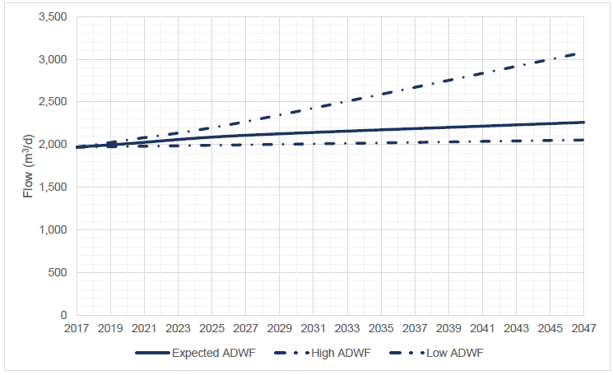

### **30-Year Long Term Plan (LTP-2021)**

KCDC is currently assembling the LTP and AMP for all Council activities, including Wastewater. As a result, the AMP is under review for the next 3 years. Cardno were engaged in financial year 2019/2020 to complete a full condition and capacity study on the wastewater site. This information is being fed into the LTP and AMP. Generally, findings reflect expected asset lifecycles, expectations of population growth, perception of new legislation and refined consent compliance targets.

With reference to the findings expressed in section 4.1.1, the following will need to be addressed:

* Influent filtration
* Pond capacity:
  + attained through solids (sludge) removal
  + as acquired through possible adjustment of weir height
* Pond effluent pumps (as part of current LDTA upgrades)
* Clarifier refurbishments
* Repetitive asset management cycles (as AMP)
* Growth
* New legislation
* Consent renewals

## Fencing and Signage

Condition 37 requires perimeter fencing and signage.

### **Compliance**

Existing fencing has been maintained.

In accordance with condition 3, the Optimisation Study recommended that a stock fence should be put in place in order to protect plantings. The grazing agreement of the adjacent tenant has been re-worked, asking them to avoid new planting areas.

Recent events in the wastewater industry have indicated that Council should fully fence the LDTA area with quality fencing, and perimeter signage warning people to stay out of the LDTA was recommended. In this case, fences will be 8ft tall.

Procurement commenced in September and, with delays in revising the tenancy agreement with the current grazing tenant, first site activities were recorded in December 2020.These upgrades should complete by end February 2020.

## Implementation of Changes to LDTA

Condition 5 requires KCDC to implement changes to the LDTA as per Condition 4.

### **Compliance**

As per the Optimisation Report requirements, KCDC has engaged Cardno for the detail design, tender support, construction administration and project management of the automation of the LDTA distribution system to improve distribution uniformity.

LDTA upgrades: Refurbishment work to effluent dispersion/irrigation lines on the LDTA was carried out with ground maintenance. Five out of the six LDTA zones have been correctly levelled, with the remaining zone currently being levelled out to reduce minor ponding of effluent.

A contract for pumping station upgrades and effluent dispersion network upgrades went to tender 12 August 2020. The tender closed 9 September 2020, having received 2 tenders. Evaluation of these tenders and award of contract was completed in December 2020. Construction will commence in January 2021, with completion expected in mid-April, however, in order to expedite this work (and in securing equipment at risk of delay due to international supply and COVID-19 supply/ shipping issues) KCDC have already taken delivery of the necessary pumps and valves.

## Planting for the LDTA upgrades

Conditions 33 to 36 require suitable planting within the LDTA and perimeter.

### **Compliance**

A number of perimeter planting options were investigated in conjunction with NHoŌ. A planting plan has been agreed, including harakeke and mānuka planting along the northern and western side as per the Optimisation Study Report.

Spring/ Summer: Mānuka will be planted on the northern boundary/buffer land, and an 8ft fence will be erected this season. Currently suitable harakeke is not available in the area, so nursery work has been engaged by KCDC to see harakeke for next planting season (autumn). Access issues with the tenant are now resolved, for which discussions were lengthy and involved a new lease. Issues arising from planting now falling in the Summer period will be resolved, such as local drip-irrigation to ensure the reliable uptake of saplings.

Autumn: Manuka will be planted on the western boundary. All harakeke will be planted. This will be completed in the next season. Fencing (8ft tall) was planned for this season too, but is likely to be completed much earlier.

The majority of the preparatory grounds maintenance, as well as realigning the bund, along the western fence line has been completed to create space for planting.

# Compliance Monitoring and Analysis

## Maximum Discharge Rate

Condition 9 and 10 permits the discharge of treated wastewater from the Ōtaki wastewater treatment plant into the Land Discharge Treatment Area (LDTA), at a maximum rate of 2,820m³/day and 155mm/day application depth.

### **Compliance**

Figure 5-1 shows the flow volume discharged to the LDTA. Automated controls are in place to lock the effluent pumps out at 2,800m³/day, ensuring the maximum rate of 2,820m³/day is not exceeded.

*Figure 5-1 Treated Effluent Discharged to LDTA*

## Wet Weather Storage

Condition 11 requires 5000m3 of wet weather storage capacity at the site, and assessment of predicted inflow volumes and population.

### **Compliance**

As per condition 11, KCDC’s storm flow buffering pond is 5,200m3 and was maintained for use during the compliance period. The pond was kept empty throughout the year, and used only for temporary storm storage events as wet weather conditions and discharge volume dictated.

This consent stipulates that a predicted inflow of 2,090m3/day to the WWTP was calculated based on a Ōtaki resident population of 6,520 in 2035. Section 4.1.1 shows that this storage is likely to be exceeded before expiry of this consent, if Ōtaki’s population continues to grow as currently predicted (and as interpreted by Cardno under section 4.1.1).

## Monitoring of Wastewater Flows

Condition 14 requires daily records of influent wastewater flow, the treated effluent volume discharged to the LDTA, and which zones were irrigated.

### **Compliance**

Refer to Appendix A for flow records, and refer to section 5.1.1 for discussion on the application volume and rate.

## Pond Effluent Quality

As per condition 15, weekly records of dissolved oxygen, weather conditions (Temperature), pond appearance and odour, are presented in Appendix A.

Condition 16 of the resource consent require the consent holder to monitor the following parameters in the combined pond effluent:

* BOD5 (g/m³)
* Non-filterable residue (suspended solids) (g/m³)
* E. coli (MPN/100mL)
* Faecal coliforms (MPN/100mL)
* Ammonia (g/m³)
* Nitrate (g/m³)
* Nitrite (g/m³)
* Total Nitrogen (g/m³)
* Total Phosphorus (g/m³)
* Dissolved Reactive Phosphorus (DRP) (g/m³)
* pH

**Nitrite**

From the conditions required in condition 16, the following parameters were not monitored during the whole period:

* Nitrite (g/m³)

As stated in the 2018/2019 annual consent compliance report to GWRC, and further elaborated on in a letter from Richard Millican, KCDC did not monitor the Nitrite in the pond effluent due to it being an unstable form of nitrogen and with notably low concentrations (generally less than 0.1g/m³). For reference, results from bore and spring testing taken over the last 6 months have primarily read <0.015g/m³ which is the lowest reading possible on the test kits used by the KCDC Laboratory.

In January 2020, the KCDC Laboratory obtained and trialled new testing kits to measure the nitrite concentrations in the ground water (monitoring bores) and spring water. As per comments from Ara Heron (Hill Laboratories): under condition 16 in GWRC’s 2017-2019 consent report to KCDC, nitrate was not tested due to such low concentrations being found in raw effluent. However, KCDC Laboratory staff will now trial nitrite testing in the ponds for 6 months, with the first test being taken in November. KCDC will continue to monitor the bores, and will come back in April 2021 with a report or letter discussing both findings.

**2019/2020 Monitoring Reporting Improvements**

Please note that boxplots have also been included, as per recommendation from Dr Cromwell in the GWRC 2017-2019 report to KCDC. KCDC do not believe these boxplots offer a better understanding of the data graphed, and have therefore also provided graphs similar to those in the 2018/2019 annual consent compliance report. KCDC will be discussing this in future with GWRC, in order to decide how best to plot the data that is collected to assist our stakeholders in their interpretation.

In previous reports, graphs have shown the combined average of the Pond A and Pond B treated effluent quality. Since Pond A and Pond B flow by gravity on a combined line to the LDTA, and both effluents are monitored individually. Therefore, each point in the graph represented the average of the two pond effluents to allow compliance assessment against the consent criteria.

Since compliance for this consent is in monitoring undertaken at the outlet (to the land discharge and treatment area) of each of Ponds A and B, these have nw been graphed seperately. Discussion is currently underway to install a sampling point to collect samples to more accurately measure compliance for this condition (i.e. a genuine combined sample). Compliance limits are drawn on the graph, with the key identifying the number of samples not to exceed that specified concentration (i.e. >8 out of 12, or >2 out of 12).

The following sub-sections graphically demonstrate compliance with the treated effluent standards for ScBOD5, TSS, faecal coliforms, ammoniacal nitrogen and DRP, prior to discharge to the Land Discharge and Treatment Area, as specified in Condition 17.

#### Soluble Carbonaceous Biochemical Oxygen Demand (ScBOD5)

Figures 5-2 to 5-2c demonstrate full compliance for both Pond A and Pond B.

*Figure 5-2 ScBOD5 Concentration in Pond A Effluent*

*Figure 5-2a ScBOD5 Concentration in Pond A Effluent – Boxplot*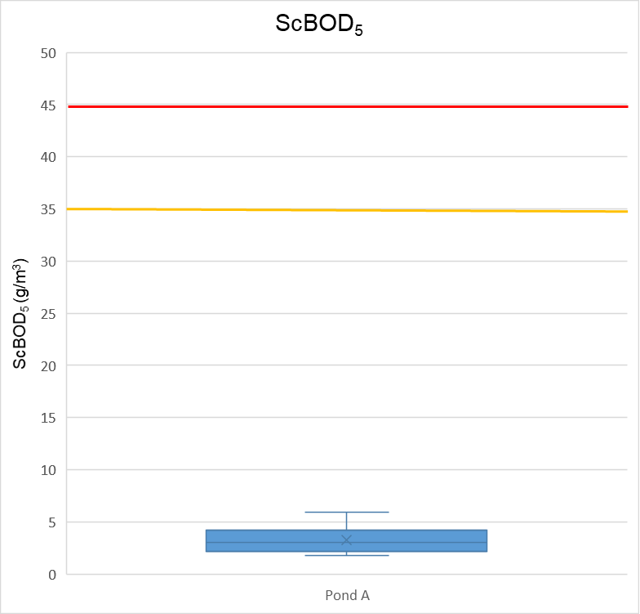

*Figure 5-2b ScBOD5 Concentration in Pond B Effluent*

*Figure 5-2c ScBOD5 Concentration in Pond B Effluent - Boxplot*

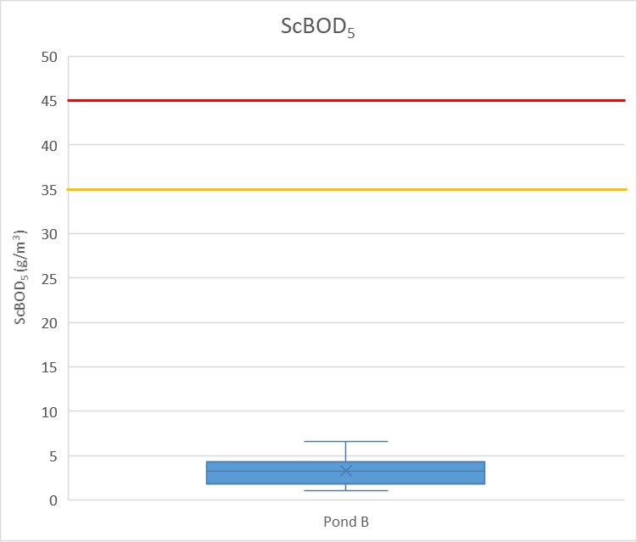

#### Total Suspended Solids (TSS)

Figures 5-3 to 5-3c demonstrate full compliance for both Pond A and Pond B.

*Figure 5-3 TSS Concentrations in Pond A Effluent*

*Figure 5-3a TSS Concentrations in Pond A Effluent – Boxplot*

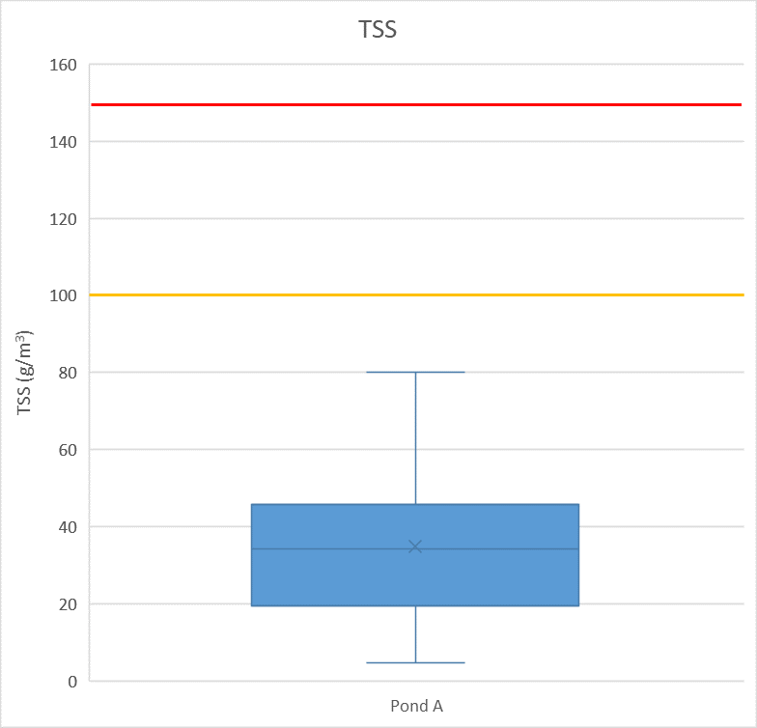

*Figure 5-3b TSS Concentrations in Pond B Effluent*

*Figure 5-3c TSS Concentrations in Pond B Effluent - Boxplot*

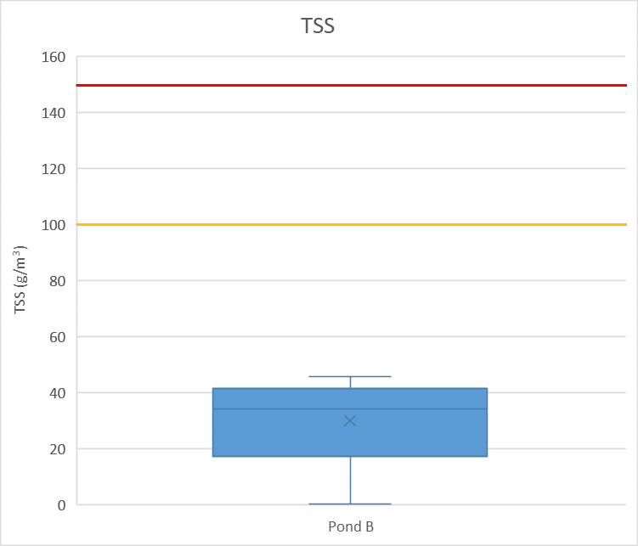

#### Faecal Coliforms

Figures 5-4 and 5-4a demonstrate compliance with three triggers of the lower limit (>8 out of 12 - 120,000 cfu/100mL), and one trigger of the upper limit (>2 out of 12 - 50,000 cfu/mL) in Pond A.

*Figure 5-4 Faecal coliforms in Pond A Effluent*

*Figure 5-4a Faecal coliforms in Pond A Effluent - Boxplot*

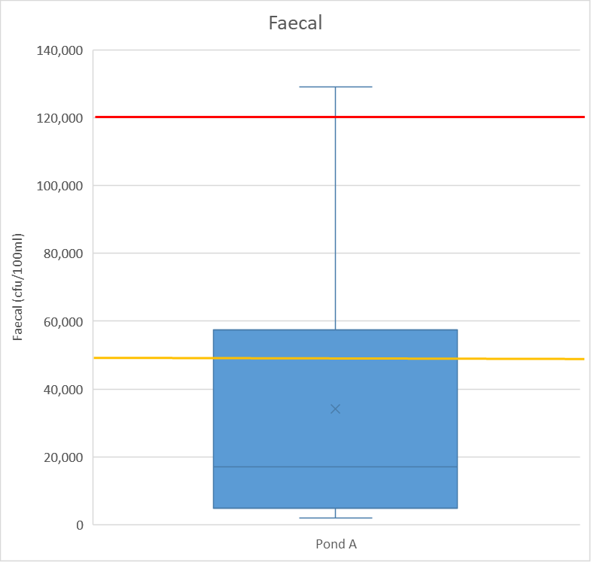

Figures 5-4b and 5-4c demonstrate general compliance with two triggers of the lower limit, and two triggers of the upper limit in Pond B.

*Figure 5-4b Faecal coliforms in Pond B Effluent*

*Figure 5-4c Faecal coliforms in Pond B Effluent - Boxplot*

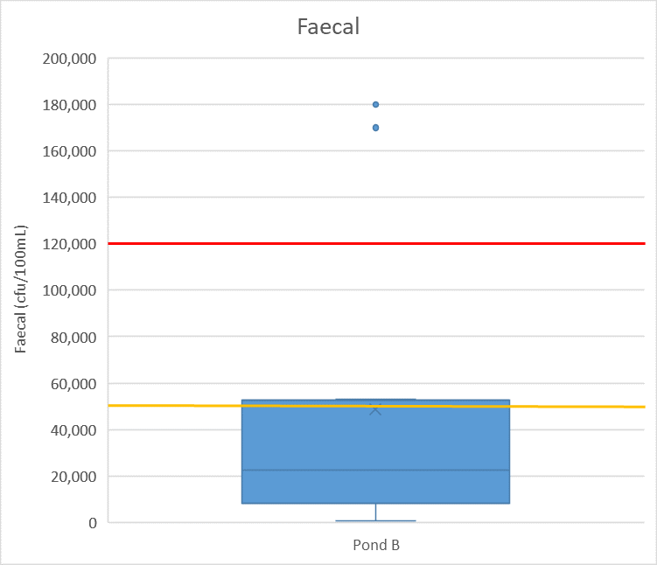

KCDC consider the high readings may have occurred because:

* Winter rainfall: spikes have occurred during winter months when rainfall is common, and therefore it is possible that surface and ground water made its way into the influent coming into the WWTP.
* Waterfowl: there is an abundance of waterfowl at this plant, and KCDC believe this could have an effect on the faecal levels in the ponds. Waterfowl have been seen in significant numbers on the water of the effluents ponds, as well as the outskirts. There is a high chance that these high readings are from faeces produced by the waterfowl in and around the effluent ponds.

KCDC have observed a rising trend at the end of June, and these data will be monitored closely, along with attending wildfowl numbers.

#### Ammoniacal Nitrogen

Figures 5-5 and 5-5a demonstrate results in Pond A triggered the lower limit 7 times (two of which were by 0.5g/m3), and upper limit 4 times (two of which were by <1g/m3).

*Figure 5-5 Ammoniacal Nitrogen Concentration in Pond A EffluentFigure 5-5a Ammoniacal Nitrogen Concentration in Pond A Effluent- Boxplot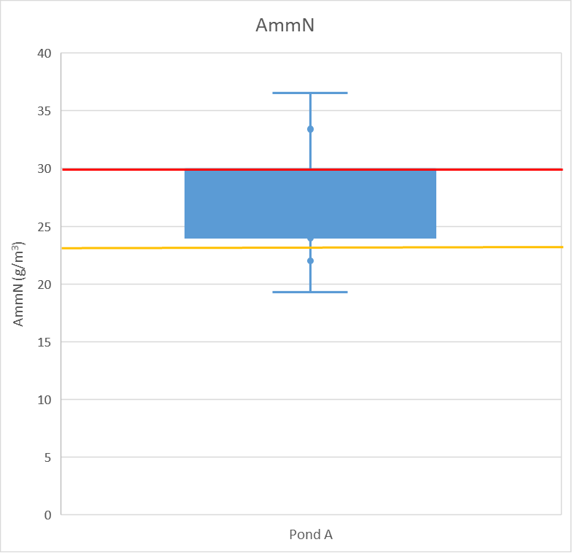*

Figures 5-5b and 5-5c demonstrate results in Pond B triggered the lower limit 5 times, and upper limit 5 times.

*Figure 5-5b Ammoniacal Nitrogen Concentration in Pond B Effluent*

*Figure 5-5c Ammoniacal Nitrogen Concentration in Pond B Effluent - Boxplot*

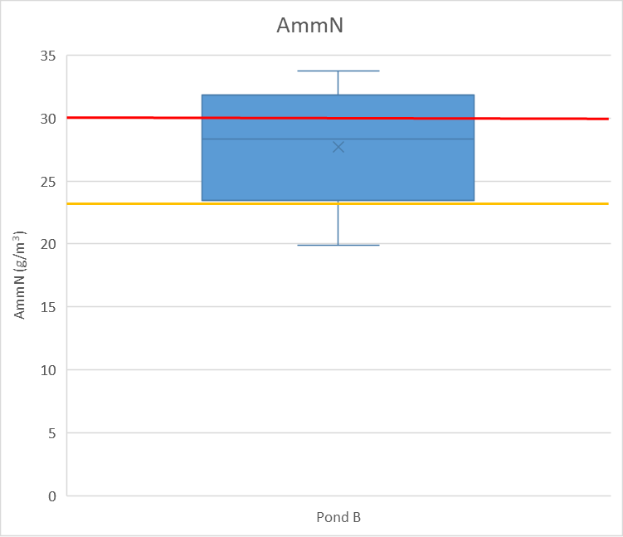

As the Ōtaki WWTP is located in the industrial area of Ōtaki, there are a few businesses that produce cleaning supplies. There were multiple incidents at the inlet, oxidation pond, and pump station where there is evidence of a cleaning product being disposed of into the wastewater system in significant amounts.

Investigation into one business by KCDC’s Compliance Team has shown that it is likely to be their product. Our Laboratory team have approached external testing providers, and it was agreed that there were no key identifying compounds that could be used to indicate any specific product or producer. One suspected product is used to clean moss, mould, and lichen, which would explain the algae death in the effluent ponds (also illustrated by a dark band around the wave-band of each pond at that time). As algae is used to lower levels of ammonia, this would explain the high readings in September through to November, as this was when the dumping incidents occurred.

The WWTP staff have tried to reverse the adverse effect on the algae, but due to the business still producing their cleaning products, it is likely this will continue to effect the algae levels in the effluent ponds. KCDC will continue to investigate and monitor this issue, and approach suspected breaches of the District’s current Trade Waste Bylaw as events are discovered. This key suspect is being monitored closely.

As well as the algaecide discussed above, KCDC Laboratory staff have advised that waterfowl faeces also contains a high concentration of ammonia, and this could also be a contributing factor to the high Ammoniacal nitrogen results in the ponds.

The data for next reporting year (2020/2021) suggest this parameter declines again from the ‘peak’ plot points declared for this reported period.

Appendix C contains a number of images with explanatory notes regarding the significance of the events seen at the influent of, and subsequent process stages in, the Plant for which local cleaning chemical dumping is suspected, as also discussed elsewhere in this report.

#### Dissolved Reactive Phosphorus (DRP)

Figure 5-6 and 5-6a demonstrates general compliance, with 2 triggers of the lower limit (>8 out of 12), and 1 trigger of the upper limit (>2 out of 12).

*Figure 5-6 DRP Concentration in Pond A Effluent*

*Figure 5-6a DRP Concentration in Pond A Effluent - Boxplot*

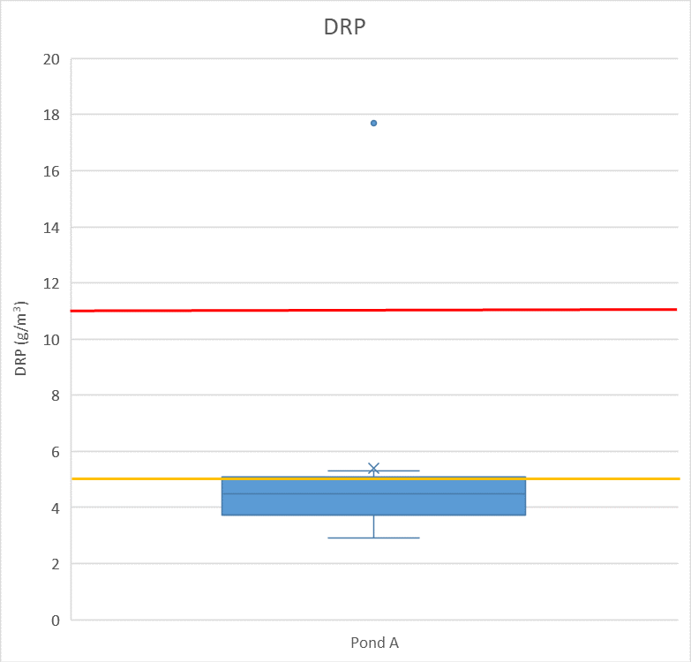

Figures 5-6b and 5-6c demonstrates general compliance, with 2 triggers of the lower limit (>8 out of 12), and 2 triggers of the upper limit (>2 out of 12).

*Figure 5-6b DRP Concentration in Pond B Effluent*

*Figure 5-6c DRP Concentration in Pond B Effluent - Boxplot*

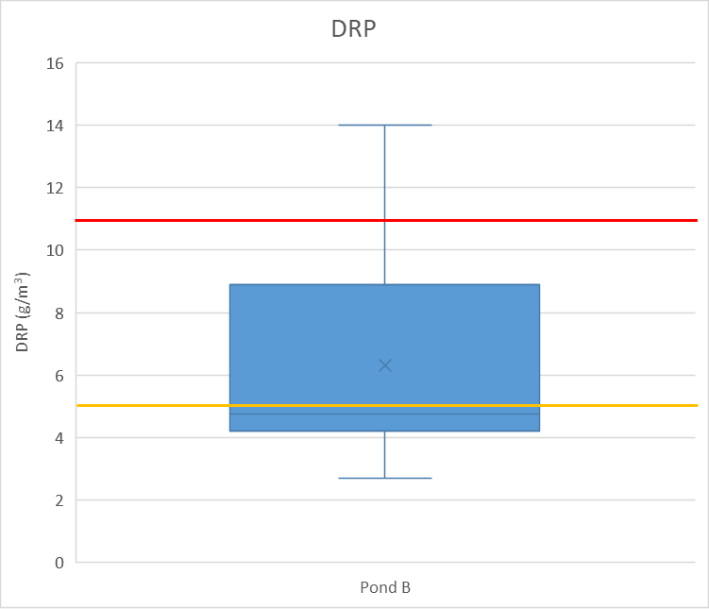

KCDC Laboratory staff believe that products produced at the cleaning facility contains phosphate which is a surfactant. As mentioned in section 5.4.1.4, the dumping incidents would therefore have a great effect on the levels of DRP which can be seen in the graphs below. There were no dumping incidents in February 2020 or June 2020, so KCDC can only assume the spikes seen below are samples that should have been investigated.

The data for next reporting year 2020/2021 suggest this parameter is to decline again.

## Ground Water and Spring Water Quality

Condition 18 specifies monitoring of ground water levels and water quality at bores 1, 2, 3, 4, 5, 6, 7 and water quality in the spring, for the following parameters:

* BOD5 (g/m³)
* Chloride (g/m³)
* E. coli (cfu/100mL)
* Ammonia (g/m³)
* Nitrate (g/m³)

### **Compliance**

Full bore monitoring records are provided in Appendix A.

### **Non-Compliance - E. coli and Soluble Inorganic Nitrogen (Condition 19)**

Condition 19 specifies the following limits for water quality monitoring in bores four and five (from Condition 18):

* E. coli (100mpn/100ml (100cfu/100mL)
* Soluble Inorganic Nitrogen (11.3g/m³ as N)

Table 5-1 demonstrates that sampling of bores 4 and 5 were generally in full compliance with the limits stated by condition 19, apart from an exceedance on 18 February 2020. KCDC believe this exceedance may have been a sampling error that should have been resampled. As can be seen from the table below, data collected either side of this exceedance fully complied.

*Table 5-1 Water Quality – Bores 4 and 5*

|  |  |  |  |  |
| --- | --- | --- | --- | --- |
|  | **Bore 4** | | **Bore 5** | |
| **Sample Date** | **E.coli cfu/100ml** | **TN 0.45 Filter (g/m³)** | **E.coli cfu/100ml** | **TN 0.45 Filter (g/m³)** |
| 08-Jul-19 | - | 2 | - | 3 |
| 21-Aug-19 | - (<1) | 2 | 5 | 9 |
| 10-Sep-19 | * | 1 | 4 | 8 |
| 11-Oct-19 | - | <1 | 2 | 6 |
| 21-Nov-19 | - | 2 | 1 | 2 |
| 04-Dec-19 | * | <1 | 1 | 1 |
| 24-Jan-20 | <1 | 3 | 3 | 5 |
| 18-Feb-20 | <1 | 3 | 159 | 2 |
| 12-Mar-20 | 3 | 3 | 6 | 7 |
| 07-Apr-20 | <1 | - | 1 | - |
| 21-May-20 | - | <1 | - | <1 |
| 15-Jun-20 | - | 4 | - | 9 |

KCDC’s records of weather at time of samping (‘LDTA Flow’ sheet in Appendix A) show conditions were wet on 18 February 2020 where there was a breach of E.coli, highlighted in red above. Laboratory staff believe that this was surface water contamination due to the hole in the bottom of Bore 5. Since bore upgrades in the last 6 months, the KCDC Laboratory believe the sample results will be more accurate within the next 6 months as the bores flush out the previous contamination. As a monitoring measure, it has been agreed that if results exceed the limits expressed in this consent, another sample with be taken. KCDC are working on rolling out WaterOutlook for the Wastewater monitoring (Water Supply safety and compliance data systems having just been rolled out), which will allow for trigger levels and sanity checks to be set, and the capability of alerts to be sent out – eventually mounting data capture onto a hend-held electronic device.

KCDC’s Laboratory monitors E. coli levels using the Standard Method 9222D membrane filtration for faecal coliforms. If faecal coliforms are present, the membrane filter is then transferred onto a media to determine if the faecal colonies are E. coli (Standard Methods 9222I). Where there is a dash (-) in the data, there were not faecal coliforms present, thus there was no transfer to the media to determine E. coli as no colonies were present.

KCDC laboratory monitor the soluble inorganic nitrogen by filtering the sample through a 0.45 filter.

### **Non-Compliance – Reporting Non-Compliance (Condition 20)**

Condition 20 requires KCDC to notify GWRC of a breach of Condition 19, within 24 hours, and provide an investigation report within 10 working days.

There was a breach during this compliance period, on 18 February 2020, with no notification, report, or investigation was provided to GWRC. However, looking at the data points on either side of this breach, it is likely this was a sampling error that could have been resolved by a re-sample. This was under a previous manager who has since left KCDC, and the new manager has been briefed on this consent and its conditions. KCDC have spoken to the teams who are currently involved, and have stipulated that in future, any breaches will be resampled as soon as possible. As mentioned in section 5.5.2, once WaterOutlook has rolled out, any breaches will trigger an alert to staff and allow faster responses to any water quality monitoring samples that need to be addressed.

### **Compliance – Attenuation Equilibrium (Condition 21)**

Condition 21 requires KCDC to monitor, and report on water quality data from bores four, five and surface water spring, against contaminant trigger levels.

As suggested in GWRC’s 2017-2019 report to KCDC, another bore site is being sought. Laboratory staff have spoken to Winston’s Quarry management previously to gain consent to access a bore onsite. However, there will be new owners taking over, and the agreement will need to be discussed again with them.

Please note that cells highlighted in green are results of a resample conducted on Bores 1, 2, 3, and the spring, completed on 8 April 2020. This resample was completed due to unusually high results of faecal coliforms. The specified data is summarised in Table 5-2.

*Table 5-2 Bore 4, 5, and Spring Water Quality*

|  |  |  |  |  |  |  |  |  |  |
| --- | --- | --- | --- | --- | --- | --- | --- | --- | --- |
|  | **Bore 4** | | | **Bore 5** | | | **Spring** | | |
| **Sample Date** | **TN (g/m³)** | **DRP (g/m³)** | **E.coli (cfu/100ml)** | **TN (g/m³)** | **DRP (g/m³)** | **E.coli (cfu/100ml)** | **TN (g/m³)** | **DRP (g/m³)** | **E.coli (cfu/100ml)** |
| 08-Jul-19 | <1 | 0.2 | - | 6 | 0.25 | - | 1 | 0.03 | - |
| 21-Aug-19 | 3 | 0.19 | - (<1) | 10 | 0.23 | 5 | <1 | 0.01 | - (<1) |
| 10-Sep-19 | 2 | 0.18 | * | 9 | 0.3 | 4 | <1 | 0.01 | 380 |
| 11-Oct-19 | <1 | 0.22 | - | 4 | 0.04 | 2 | 1 | 0.01 | 11 |
| 21-Nov-19 | 6 | 0.18 | - | 5 | 0.25 | 1 | <1 | 0.02 | 110 |
| 04-Dec-19 | 1 | 0.17 | * | 4 | 0.25 | 1 | <1 | 0.01 | 2,900 |
| 24-Jan-20 | 2 | 0.17 | <1 | 5 | 0.31 | 3 | 2 | 0.03 | 490 |
| 18-Feb-20 | 6 | 0.17 | <1 | 6 | 0.3 | 159 | <1 | <0.01 | 840 |
| 12-Mar-20 | 1 | 0.18 | 3 | 7 | 0.31 | 6 | 2 | 0.01 | 510 |
| 07-Apr-20 | <1 | 0.2 | <1 | 3 | 0.3 | 1 | 2 | 0.01 | 5,600 |
| 08-Apr-20 |  |  |  |  |  |  | - | - | 1,000 |
| 21-May-20 | <1 | 0.36 | - | <1 | 0.35 | - | <1 | 0.02 | 2 |
| 15-Jun-20 | 3 | 0.15 | - | 8 | 0.33 | - | 1 | 0.02 | 760 |

Testing the bores commenced December 2016, and since then results for DRP have been over the limit of 0.1g/m3. Below are the average readings for DRP from December 2016 to June 2020. The averages coloured red, here, indicate those over the value of 0.1g/m3. This suggests that the limit for DRP in the bores and spring needs to be discussed, as they have been consistently as such since testing started. As mentioned in KCDC’s previous annual consent compliance reports, there is no information on groundwater studies prior to the application of this consent in 2016. However, KCDC will endeavour to carry out an investigation to determine if the attenuation equilibrium of the LDTA has been effected.

*Table 5-3 Averages of DRP from 2016 to 2020*

|  |  |
| --- | --- |
| Bore 1 | 0.029512 |
| Bore 2 | 0.759268 |
| Bore 3 | 0.630976 |
| Bore 4 | 0.240976 |
| Bore 4a | 0.063415 |
| Bore 5 | 0.171951 |
| Bore 6 | 0.021707 |
| Bore 7 | 0.021026 |

KCDC will also like to discuss the sampling of the spring and the E.coli limit. The spring is also very difficult to retrieve samples from as the flow is quite low, and almost non-existent over summer, as well as overgrown with weeds. KCDC’s wastewater operations team will be trialling prototype access &/or catchment assets to allow easier access to take reliable samples. This will be reported on in the 2020/2021 report.

As previously discussed, the spring is frequented by farm animals and waterfowl which may contribute to the high E.coli results. With regard to the E.coli limit on the spring at 100cfu/100ml, KCDC would like to understand which standard it comes from. The E.coli level for recreational water (i.e. the swimmable level set for NZ rivers) is less than or equal to 260 cfu/100mL. The E.coli level for our Stormwater / streams (that the Stormwater runs into) is set at 1000 cfu/100mL. KCDC believe the E.coli level of 100 cfu/100 ml for the spring/stream is very low considering the spring is not a bore. The spring water hits land and then forms the stream, and therefore has the potential to be contaminated by the land environment surrounding the spring/stream (i.e. bird life, farm animals, etc.).

Incident Notification

Condition 42 requires KCDC to notify GWRC of any incident which results, or could result in, an adverse effect on the environment beyond the boundary of the consent holder’s site.

### **Compliance**

No such incident occurred within the compliance period.

Appendix A

**Flow and sampling records**

Please find these attached separately in an Excel spreadsheet.

Appendix B

**Wastewater Network Management Improvement Programme**

In 2019 KCDC engaged consultant Morphum (with hydraulic modeller HAL) to commence a network performance investigation, with the intent of developing a Network Containment Standard and an asset investment programme.

|  |  |  |  |
| --- | --- | --- | --- |
|  | **Task** | **Work Programme** | **Status** |
| 2019/20 financial year | Update the wastewater network models | Update the models with current population forecasts (Ōtaki) and join the Paraparaumu and Waikanae networks to the storm basin (WPR). | Completed |
| Business as usual - existing and future system performance | Use the wastewater models to predict issue areas arising over the next 50 years by adding population growth, pipe degradation and climate change. | Completed |
| Develop a draft wet weather containment performance standard for 2021 Long Term Plan consultation | Undertake a Cost/Benefit analysis to consider the costs related to achieve a range of containment standards (in the future) to ensure the containment standard is justified and affordable.  Council will seek to optimise the costs by considering a range of options for every containment standard. | Completed |
| Draft wastewater network improvement programme for 2021 Long Term Plan consultation | Develop a proposed works program that will meet the draft containment performance target.  Program (timing) of the works based on milestone models. Provide detailed scoping required for all urgent projects (first 5 years)  Identify areas which require flow gauging or other investigations before project are implements to confirm (detailed) scope and when. | Advanced |
| Integrated private property inspection policy for wastewater and stormwater | As part of the Stormwater Strategy, Council will be developing a Bylaw to provide guidance and responsibilities for property owners to maintain their stormwater systems. The Bylaw will provide ability to require property owners to correct any illegal stormwater to wastewater systems | Ongoing |
| 2020/21 financial year | Renewal Strategy | Develop a renewal strategy and processes to identify, justify, scope and programme future network renewals including condition based renewal as well as performance based (I/I) renewals. | First draft |
| Monitoring Strategy | (including the use of pump station data, temporary flow gauging, etc.) | Partly developed |
| Emergency Response Strategy | Undertake a comprehensive risk assessment to develop response strategy | Not yet developed |
| Waste Water Strategy | Include and consolidate all wastewater objectives, target, and processes into a single strategy.  Including: | Q3-4 of financial year |
| Pump station performance monitoring tool | Using critical pump stations, undertake a review of their performance to enable a high level review of Inflow and Infiltration rates and other performance attributes.  Once data proven, develop flow analysis tool to monitor the I/I rates in each wastewater pump station catchment. | Q3-4 of financial year |
| Comprehensive I&I assessment | Undertake a detailed I&I assessment for dry and wet weather. Needs a model that has reliable dry and wet weather calibration which need to be confirmed first recalibration might be possible based on outcomes of Pump Station performance assessments. | Q4 of financial year |

|  |  |  |  |
| --- | --- | --- | --- |
|  | **Task** | **Work Programme** |  |
| 2021/22 financial year | Pilot I&I programme | Set up and implement a pilot programme for reducing I&I in a target area. This could include detailed investigation to target high priority areas, private property inspections and work on public laterals. | TBC |
| Pump station failure risk assessment | Review pump stations against risks on the failure against some good industry practices such as (1) power, (2) need for emergency storage and (3) the need for designated overflow locations. | TBC |
| Wastewater catchment plans (WWCP) | Capture the knowledge of the wastewater network performance, issues and solutions in an accessible report or web based application.  This will allow overlay with other asset areas such as flooding  The WWCP can get progressively be updated with results from the issues and actions register. | TBC |
| Overland flow mapping | Map location overland flow paths. Overland flow is a known cause of inflow of stormwater into gully traps and leaky pipes and also reason for deliberate cross connections. | TBC |
| Develop a network discharge consent | Investigate a network discharge consent application for planned wastewater overflows. | TBC |
| Planning improvement projects register | Consolidate all 'planning' / 'asset management' recommendations, from reports as they arise, into one register, including the ability to track. | TBC |
| Issues and actions register | Develop a register that can track issues to solutions. This would include the ability to link issues to solutions, to assign 'case manager', the ability to move issues into planning phase and then implementation. Issues can be raised by planning (e.g. performance assessments), operational staff and community. | TBC |
| Bench mark | Undertake the next benchmarking projects using another method/provider. | TBC |

Appendix C

**Ōtaki Wastewater Treatment Plant Suspected Dumping Incidents**

With reference to sections 5.4.1.4 and 5.4.1.5, below are photos taken of the dumping incidents experienced by the Ōtaki WWTP.

**August 2019** **–** Comparison influent/raw samples from Paraparaumu WWTP (left) and Ōtaki WWTP (right) after a dump of an unknown substance. There is an obvious difference in what the raw effluent usually looks like compared to this incident at Ōtaki.

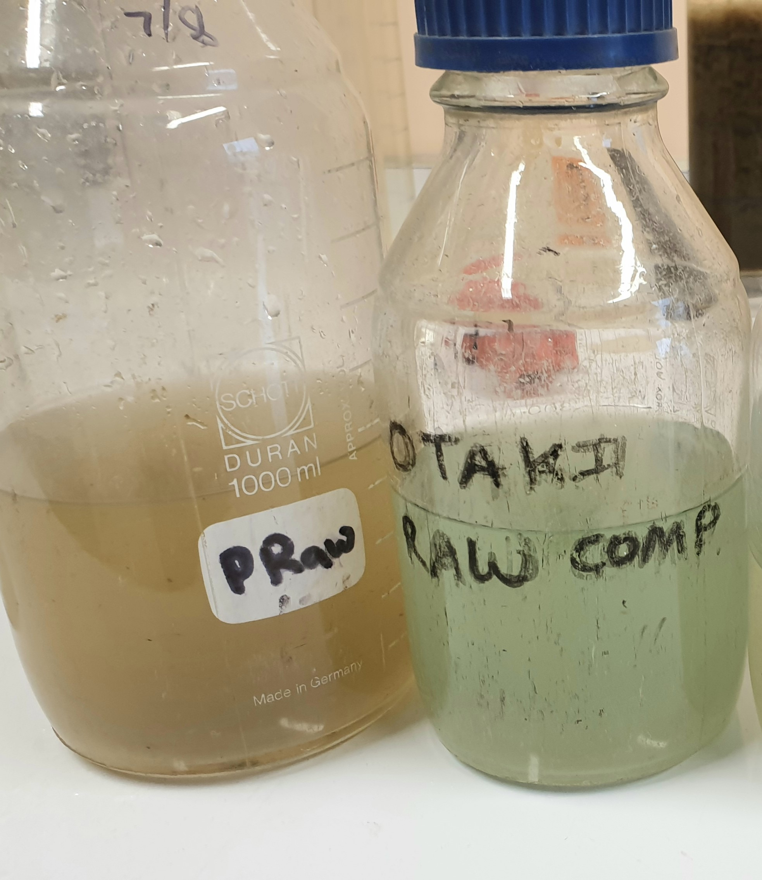

**October 2019 –** Soapy foam in the aerated biological nutrient removal (BNR) pond at the Ōtaki WWTP.

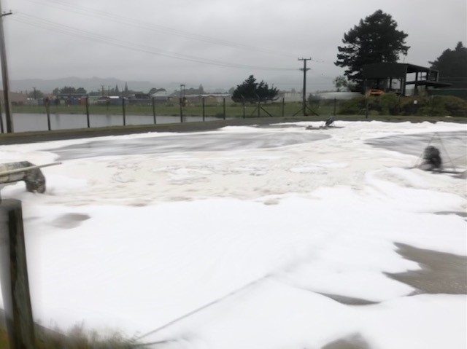

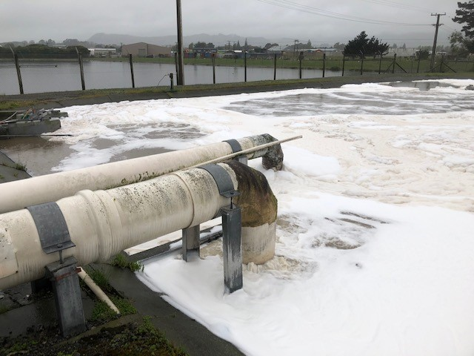

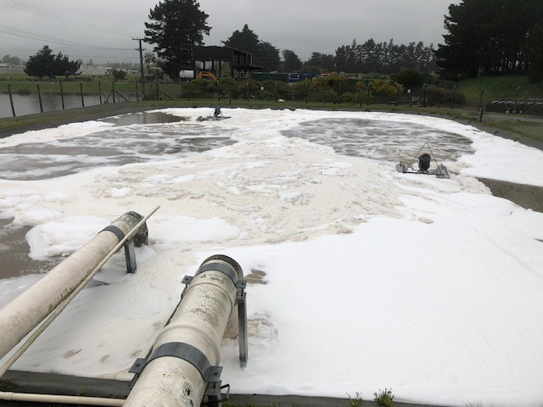

**November 2019 –** BNR pond at Ōtaki WWTP turned blue, and slightly foamy.

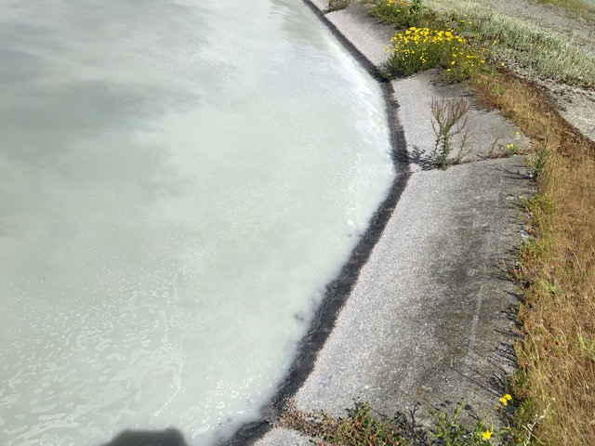

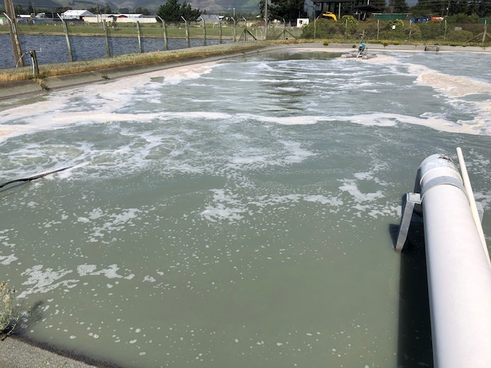

Below: Blue effluent in the clarifier.

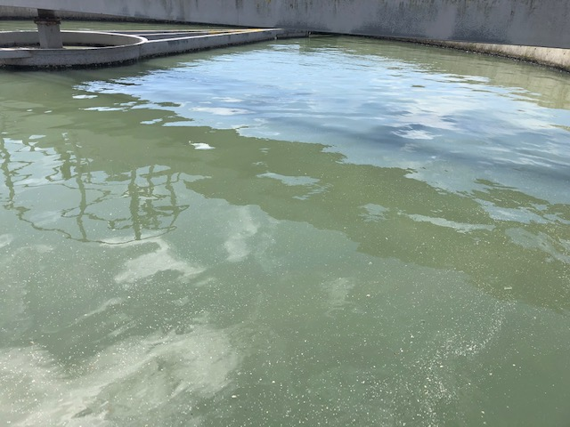

Below: Blue water, with some foam in the splitter box.

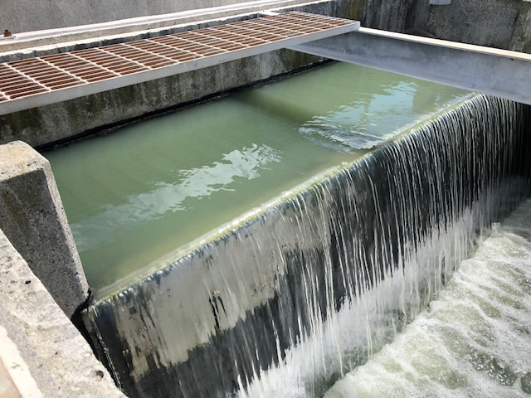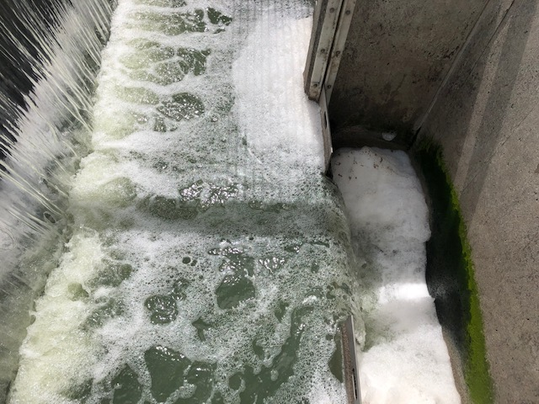

Below: Sample taken from the pump station outside of ‘The Soapbox’ business mentioned in section 5.4.1.4. This sample is clearly very blue, even more so than the sample shown in August 2019.

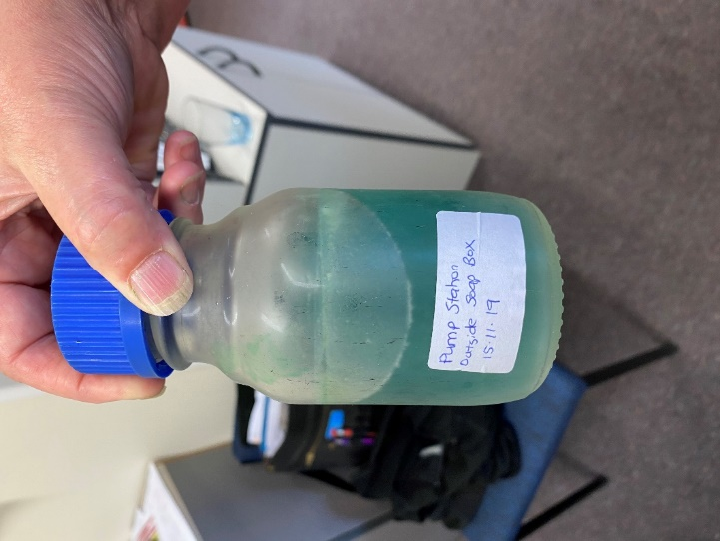

**January 2020 –** Soapy foam in the BNR pond at Ōtaki WWTP.

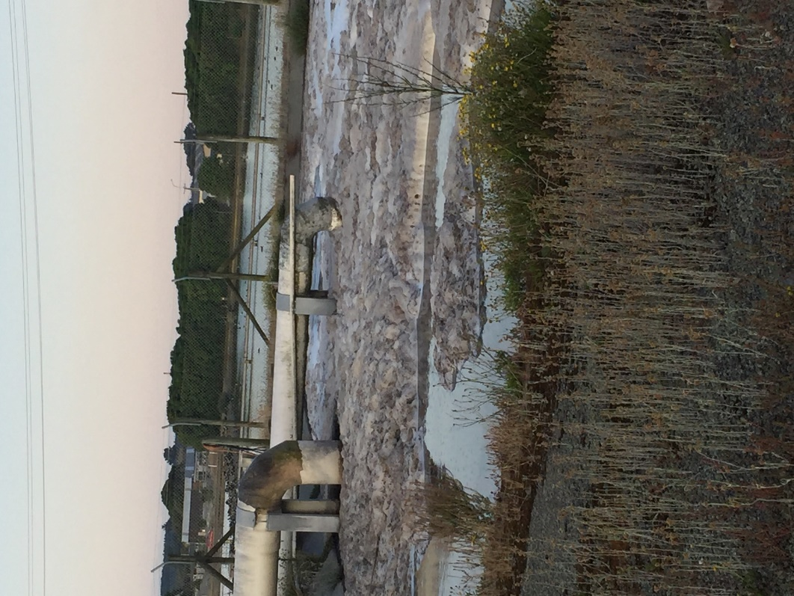

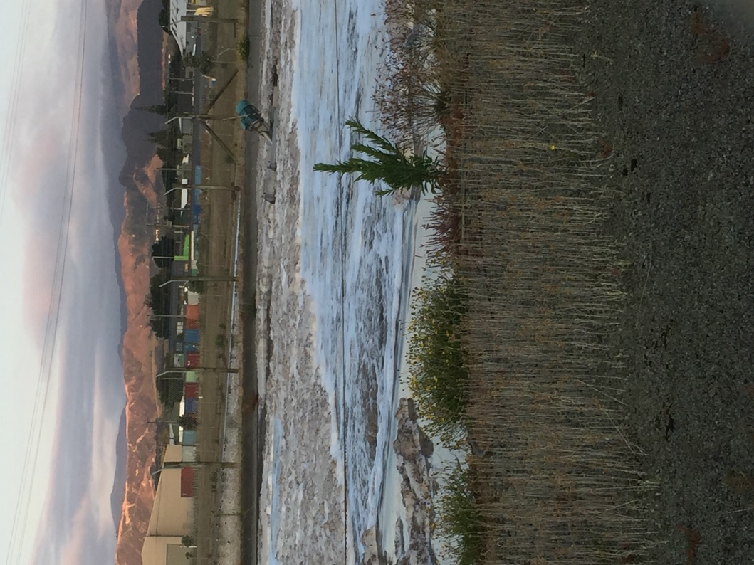

**July 2020 –** Massive foam incident in the BNR pond at the Ōtaki WWTP.

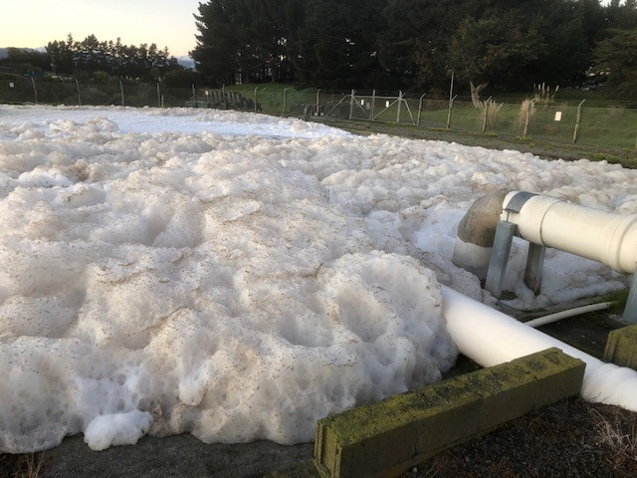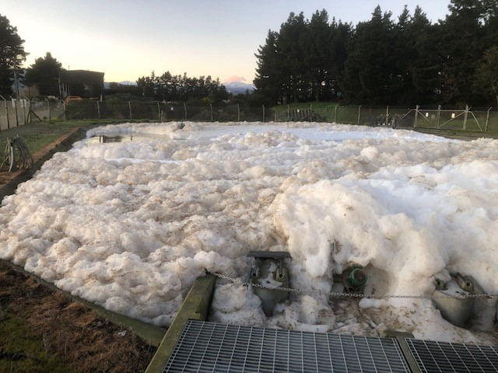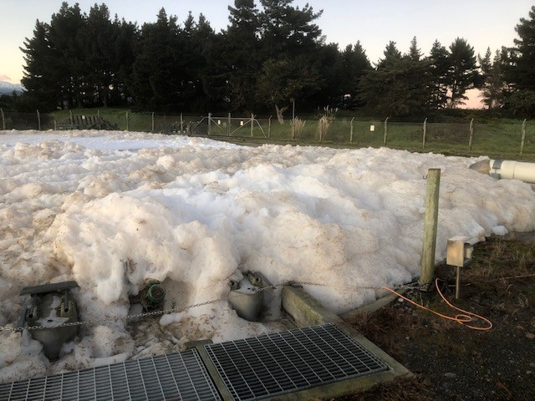

Below: Sample taken from Ōtaki sewage plant. As can be seen, it is blue and soapy.

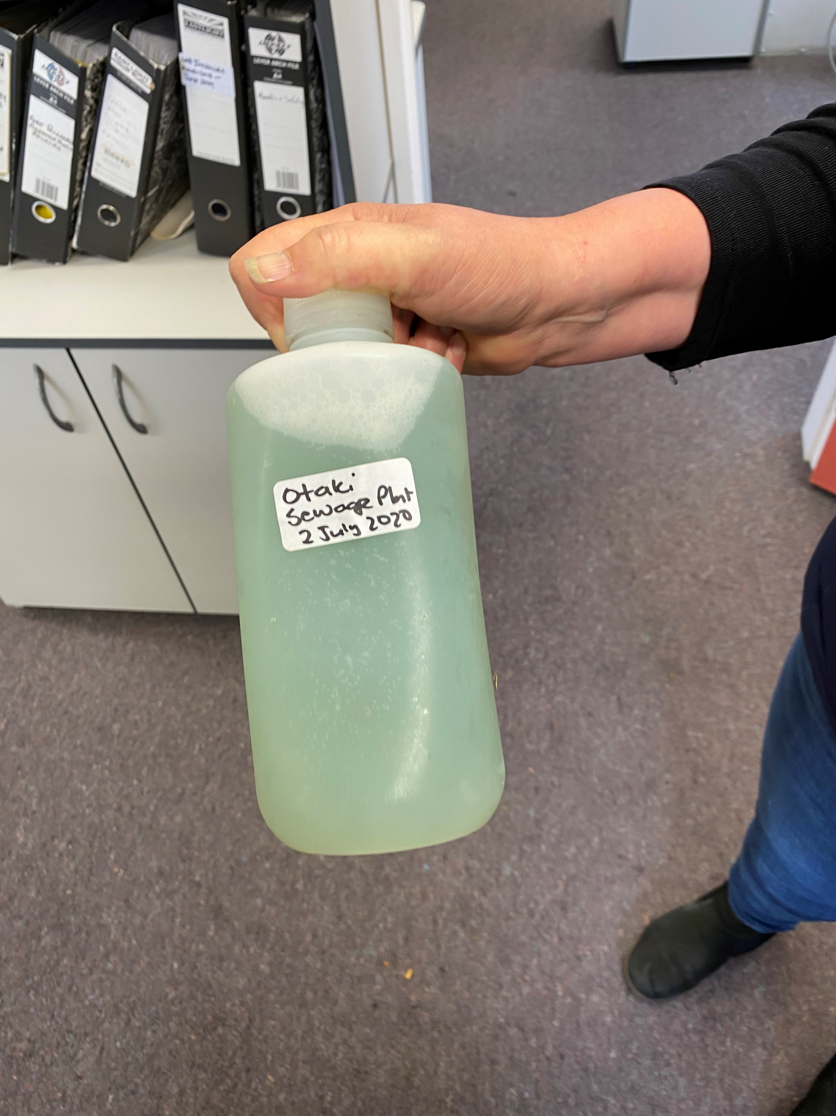

Appendix D

**Ōtaki Wastewater Treatment Plant Resource Consent No. WGN160002**

Please find a PDF of Resource Consent No. WGN160002 attached separately.